MATH 3P40 - Mathematics Integrated with Computers and Applications III

Assignment 4

Matt Laidman
5199807

April 4, 2017
Problem 1
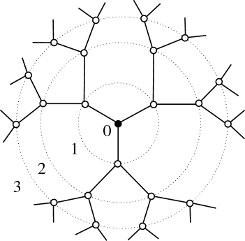Bethe Lattice, z = 3
Letbe the probability for a given bond to be open. Letbe the probability that a given site is not connected to infinity along a specific path, and letbe the probability that a given site is a part of an infinite cluster.
For any path; a site has two bonds to consider which lead away from the starting site, with two possibilities each:
- The bond is closed with probability
or:
- The bond is open with probabilityand the connected site is not connected to infinity with probability
Q can then be defined as:

Ifandandintersect on the intervalatand atwhenfor some critical probability
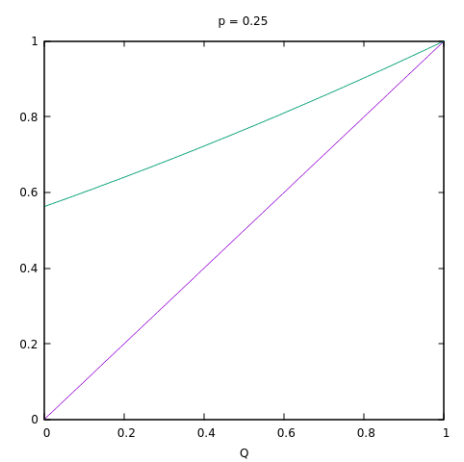
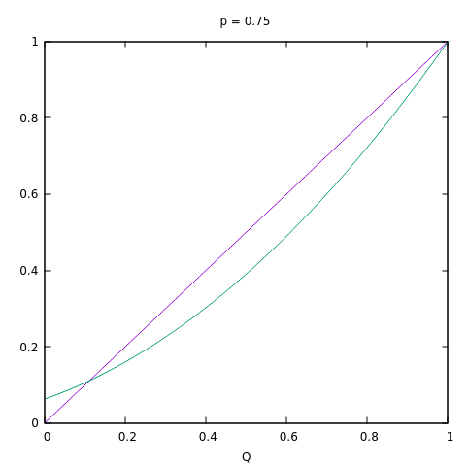

This crossover point,can then be found by finding the point when the slopes ofandare equal at

The solutions forare given by:

When

then whenas it is known thatwhen
When

then whenas it is known thatwhen
This gives the following final result for

the probability that a given site is a part of an infinite cluster, can then be defined in terms ofas the probability that the site is connected to infinity by at least one of the three paths leading out of it. This gives:

The Taylor expansion of this function foratis:

Whenthe linear term of the expansion is the largest contributor. This suggests that:
wherewhenand
The exact critical values for bond percolation on a Bethe lattice whereare therefore:

Problem 2
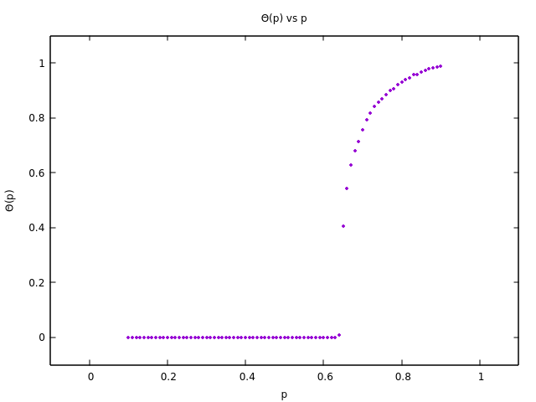
A simulation of the directed bond percolation model for a lattice of size 10000 using probabilities ranging from 0.10 to 0.90 with a step size of 0.01 produced the following plot of the density of wet sites in the bottom row verses p:

The following piecewise function was then fit to the data using gnuplot:

giving the following resulting values:

Plotting this function with the data produces the following:
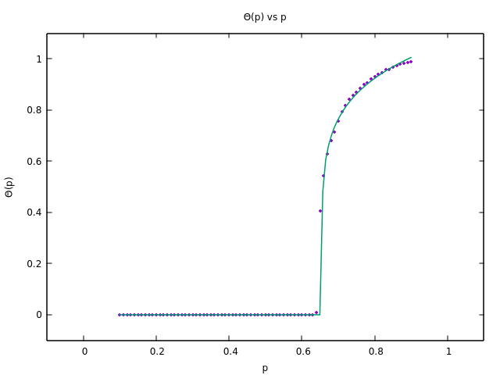
The critical probability,for directed bond percolation on a square lattice is therefore
Problem 3
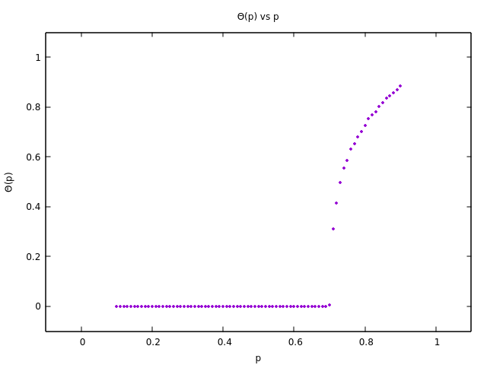
A simulation of the directed site percolation model for a lattice of size 10000 using probabilities ranging from 0.10 to 0.90 with a step size of 0.01 Produced the following plot of the density of wet sites in the bottom row verses p:
The following piecewise function was then fit to the data using gnuplot:

giving the following resulting values:

Plotting this function with the data produces the following:
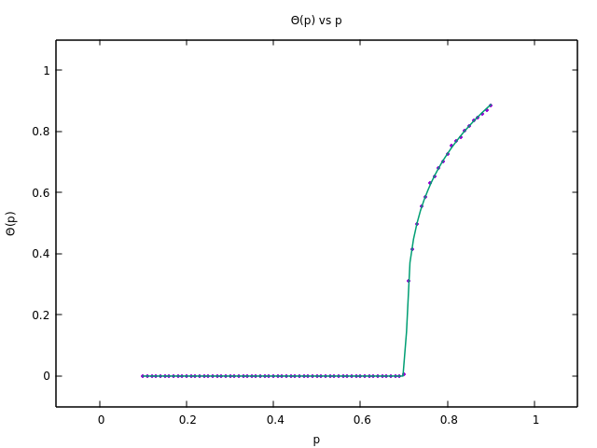
The critical probability,for directed site percolation on a square lattice is therefore

